What is the Internet?
The Internet is a worldwide network that connects millions of computers, mobile phones, and other devices. It allows people to share information and communicate with each other.

Examples
- Browsing websites
- Sending emails

What is a Website?
A Website is a collection of related web pages stored on a web server and accessed through the Internet using a web browser.
Every website has a unique address called a Domain Name.
Examples
- google.com
- amazon.in

What is a Web Page?
A Web Page is a single page of a website.
Examples
- Home Page
- About Page

Static Website
A Static Website shows the same content to every visitor.
The content does not change automatically.
These websites are created using
- HTML
- CSS
- JavaScript

Features
- Fast loading
- Easy to build
- Low cost
- No database
- Same content for everyone

Dynamic Website
A Dynamic Website changes its content according to the user, time, or database.
It uses
- HTML
- CSS
- JavaScript
- PHP / Node.js / Python / Java
- Database (MySQL, MongoDB, etc.)

Features
- User Login
- Registration
- Database
- Interactive

Examples
- Facebook
- Instagram

Frontend vs Backend

Frontend
Frontend is the part of the website that users can see and interact with.

Technologies
- HTML
- CSS
- JavaScript
Examples
- Buttons
- Images
- Forms
- Menus
- Text

Backend
Backend is the hidden part of a website that works on the server.
It handles
- Login
- Database
- Payments
- User Accounts
- File Storage

Technologies
- PHP
- Node.js
- Java
- Python
- .NET

Databases
- MySQL
- MongoDB
- PostgreSQL

Client-Server Architecture
When you open a website, two main components work together:

Client
The Client is the user's device or browser (such as Chrome, Edge, or Firefox). It sends a request to access a website.

Server
The Server is a powerful computer that stores website files and sends them to the user's browser.
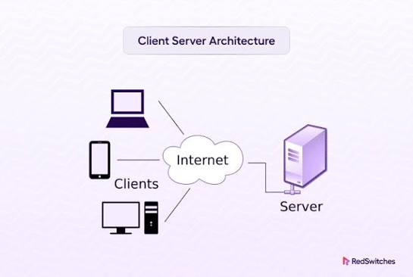

Browser Working
A Web Browser is software used to open and display websites.
Examples
- Google Chrome
- Microsoft Edge
- Mozilla Firefox
- Safari
- Opera

Browser Working Steps
- User enters a website address (URL).
- The browser sends a request to the server.
- The server processes the request.
- The server sends HTML, CSS, JavaScript, images, and other files.
- The browser renders these files and displays the web page.

HTTP vs HTTPS

HTTP
HTTP stands for HyperText Transfer Protocol.
It is used to transfer data between the browser and the server.

Features
- Not encrypted
- Less secure
- Uses Port 80
Example
http://example.com

HTTPS
HTTPS stands for HyperText Transfer Protocol Secure.
It encrypts the data exchanged between the browser and the server using SSL/TLS.

Features
- Encrypted
- Secure
- Protects passwords and payment details
- Uses Port 443
Example
https://example.com

What is a Code Editor?
A Code Editor is a software application used to write, edit, and manage source code for websites, applications, and software.

Popular Code Editors
Code Editor | Developer | Free/Paid
Visual Studio Code (VS Code) | Microsoft | Free
Sublime Text | Sublime HQ | Free Trial / Paid
Notepad++ | Don Ho | Free
Brackets (legacy) | Adobe (community maintained) | Free
Vim | Vim Community | Free

HTML5

What is HTML?
HTML stands for HyperText Markup Language.
It is the standard markup language used to create the structure of web pages.
HTML tells the browser how content such as headings, paragraphs, images, links, and tables should be organized.

HTML is not a programming language.
It is a Markup Language because it uses tags to describe the structure of content.

Uses of HTML
- Create web pages
- Display text
- Add images
- Create tables
- Build forms
- Add videos and audio
- Link pages together

HTML Versions
Version | Year
HTML 1.0 | 1993
HTML 2.0 | 1995
HTML 3.2 | 1997
HTML 4.01 | 1999
XHTML | 2000
HTML5 | 2014 (Living Standard continues to evolve)

